**CLOUD COMPUTING**



**SUBMITTED TO**  
SIR WAQAS SALEEM

**SUBMITTED BY**  
HAMNA MAHMOOD  
2023-BSE-025

BSE V-A

**Lab 5**

**Lab Title**

**Java, apt vs apt-get, snap, GUI, Vim on Ubuntu Server**

**Task 1 - Discover missing command & install Java using apt suggestion**

task1_java_suggestion.png

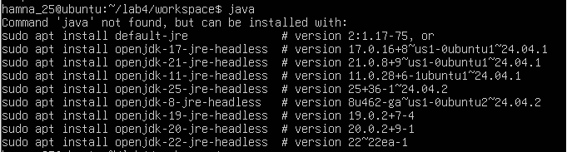

task1_java_install.png

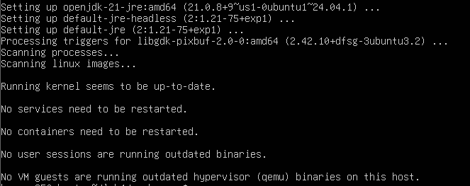

task1_java_version.png



task1_java_remove.png

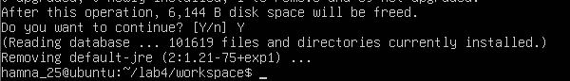

task1_java_not_found.png

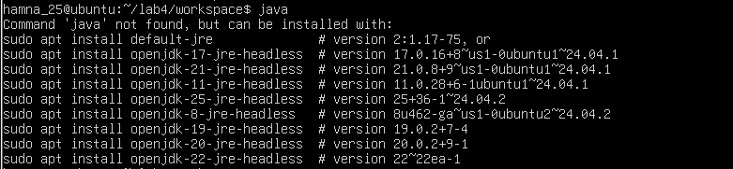

task1_hash_clear.png



**Task 2 - Install & remove Java using apt-get (explicitly)**

task2_aptget_install.png

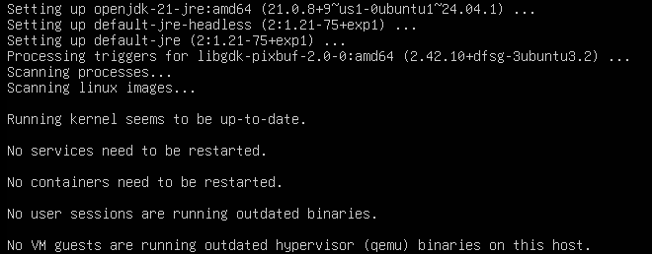

task2_java_version_after_aptget.png



task2_aptget_remove.png

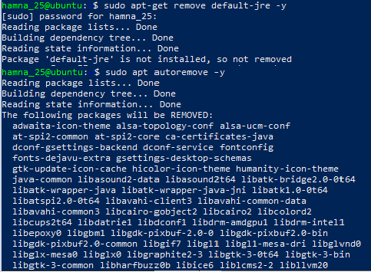

task2_hash_after_remove.png

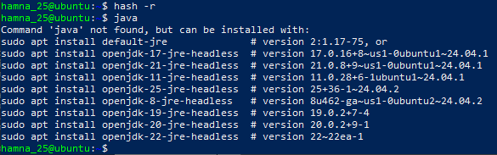

**Task 3 - apt update vs apt upgrade - run & explain**

task3_apt_update.png

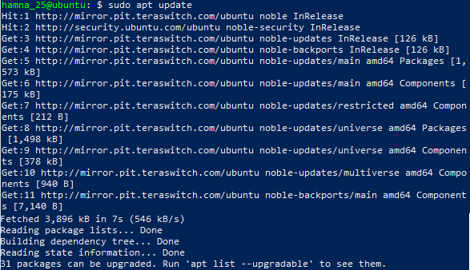

task3_apt_upgrade.png

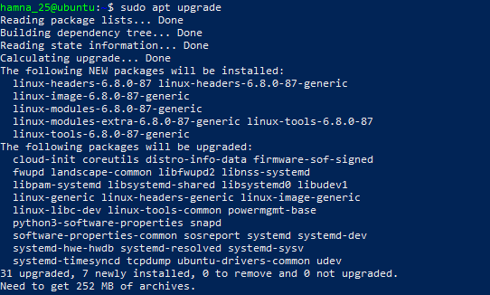

task3_explanation.png

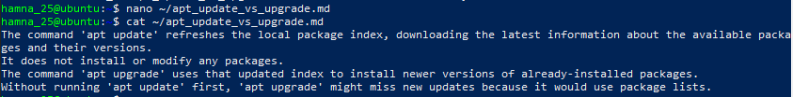

**Task 4 - Install Visual Studio Code via snap on CLI and verify (DO NOT remove Code)**

task4_snap_install.png



task4_snap_list.png



task4_code_version_or_info.png

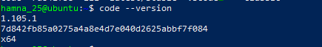

task4_snap_bin_location.png



**Task 5 - Install XFCE GUI + XRDP - minimal desktop and remote access (GUI) and launch VS Code**

task5_update.png

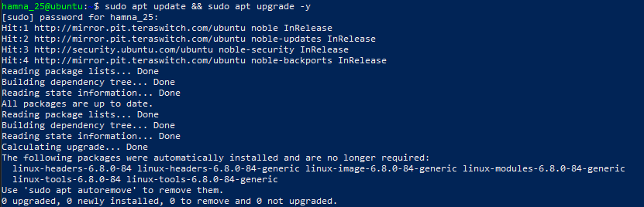

task5_xfce_install.png

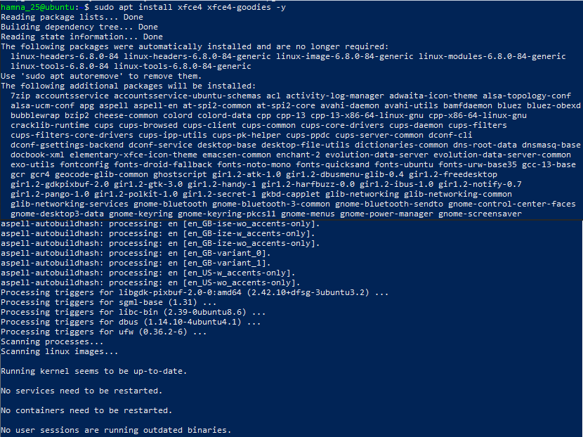

task5_xrdp_enable.png

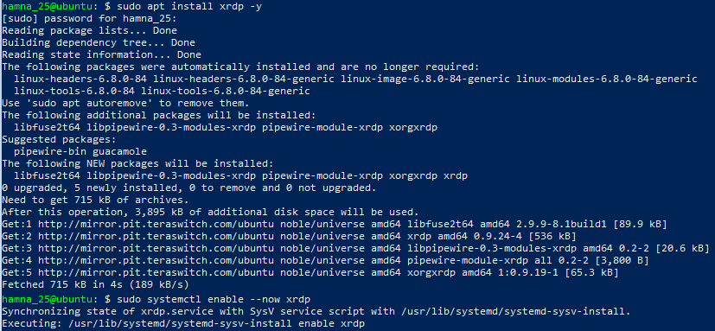

task5_xrdp_status.png

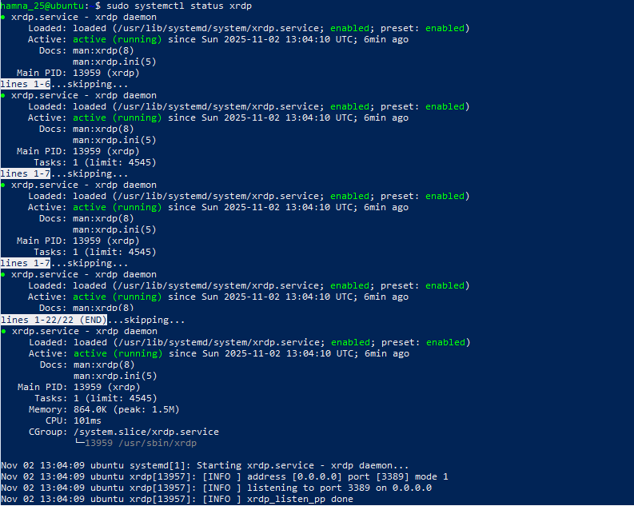

task5_xsession.png



task5_rdp_connect.png

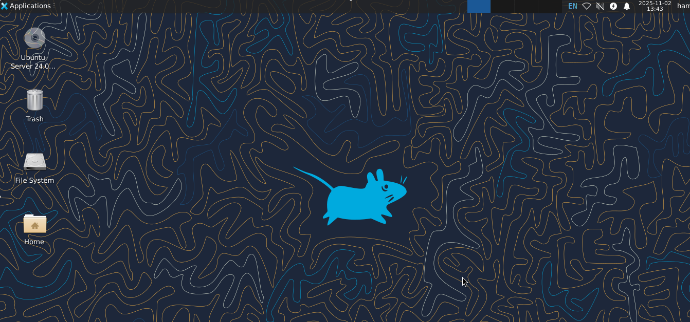

task5_vscode_launch.png

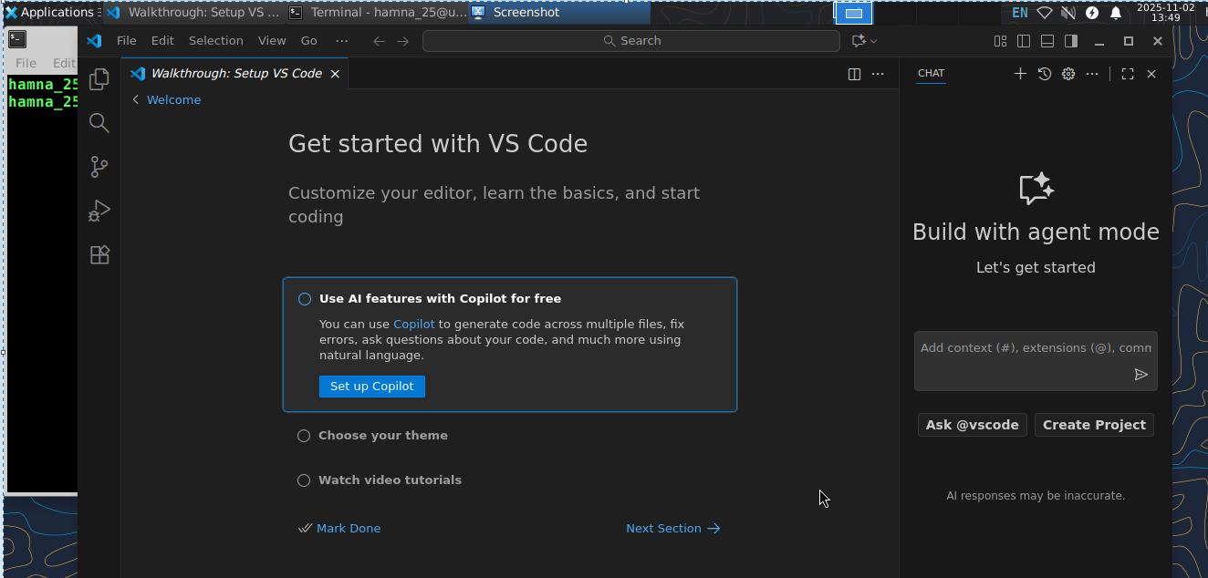

**Task 6 - Install lightdm-gtk-greeter and GUI verification - start GUI, open VS Code, take snapshot, then end (GUI)**

task6_lightdm_install.png

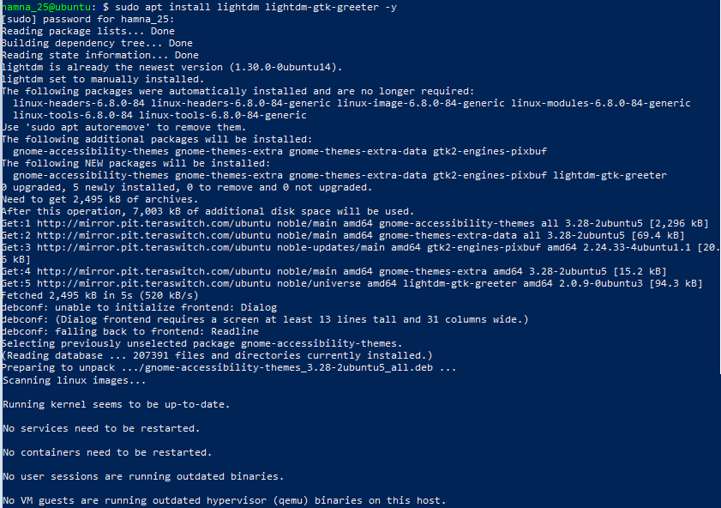

task6_lightdm_config.png

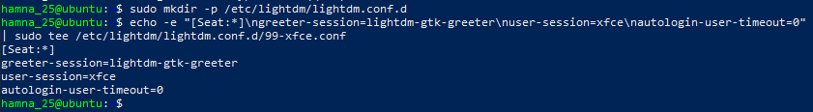

task6_lightdm_cleanup.png

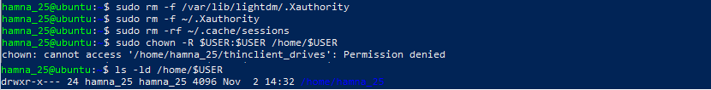

task6_lightdm_restart.png



task6_gui_enable_boot.png

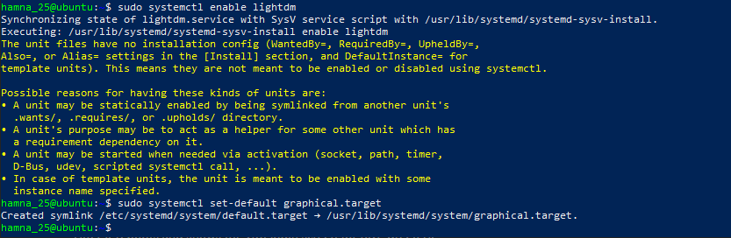

task6_after_reboot_gui.png

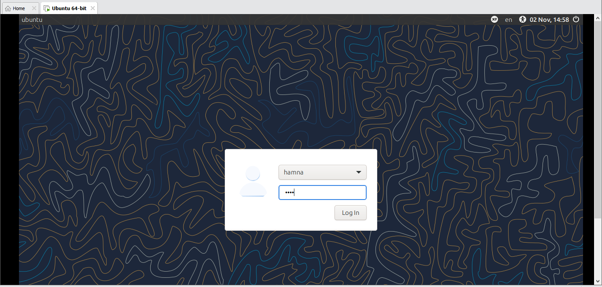

task6_gui_disable_boot.png

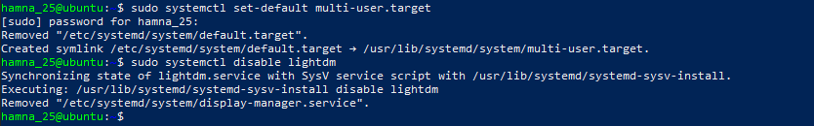

task6_after_reboot_cli.png

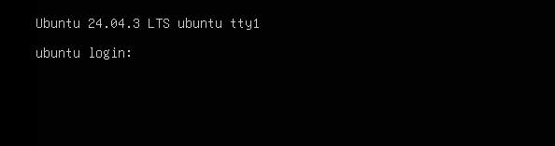

task6_gui_start.png

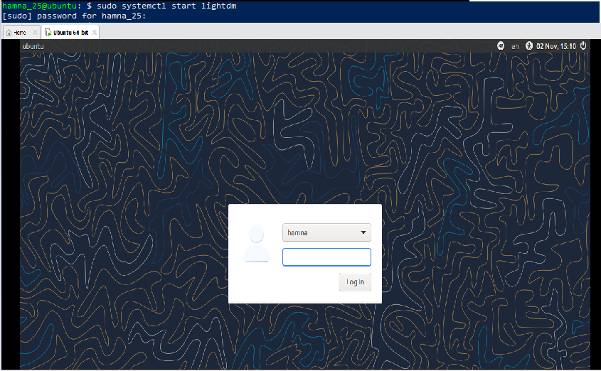

task6_gui_stop.png

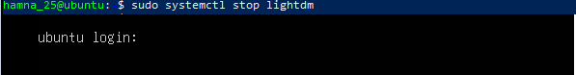

task6_gui_start_command.png



task6_vscode_launch.png

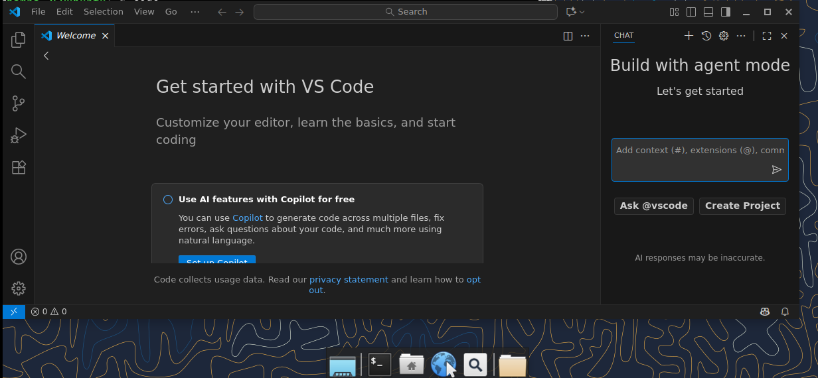

**Task 7 - Install Google Chrome by adding its apt source & key (Chrome)**

task7_install_chrome_error.png

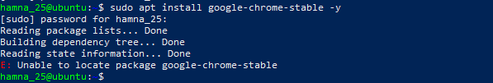

task7_ls_etc_apt.png

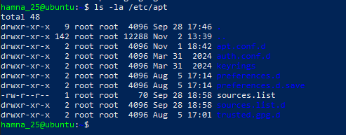

task7_cat_sources_list.png



task7_ls_sources_list_d.png

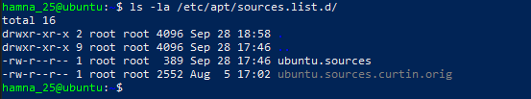

task7_cat_ubuntu_sources.png

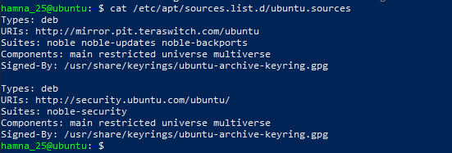

task7_edit_ubuntu_sources.png



task7_add_key.png



task7_apt_update.png

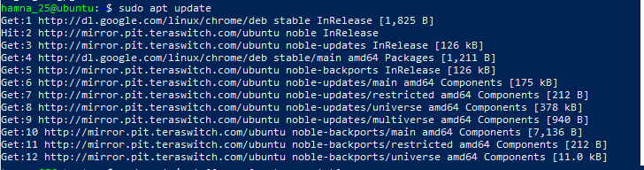

task7_install_chrome.png

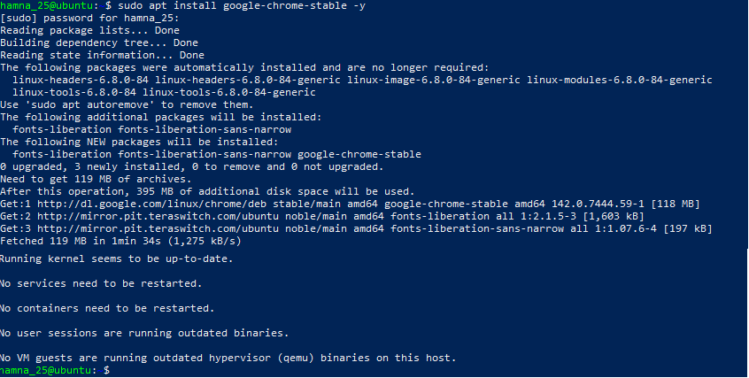

task7_alternate_remove.png

Here, in the file, links other than the official ubuntu link of http://archive.ubuntu.com/ubuntu/ was deleted.

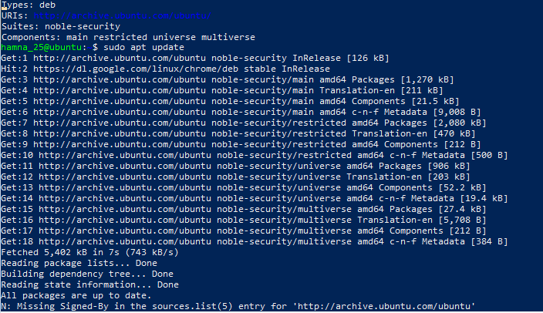

task7_alternate_edit.png

Here, the link was edited from <http://security.ubuntu.com/ubuntu/> to <http://archive.ubuntu.com/ubuntu/>

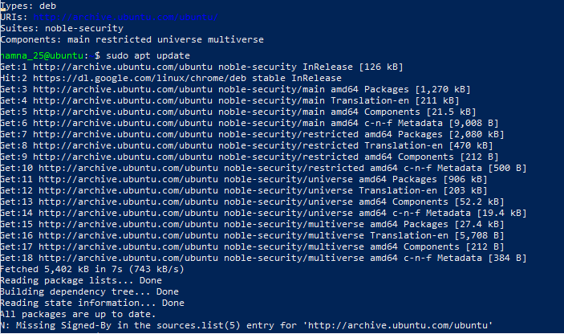

task7_remove_key.png

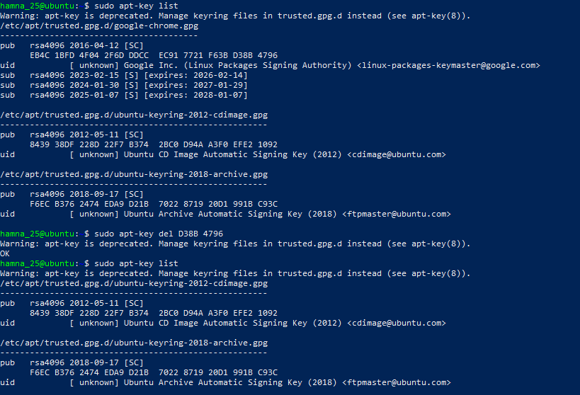

task7_create_google_chrome_list.png



task7_list_sources_after_create.png

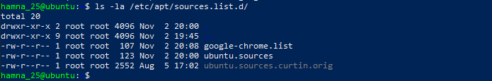

task7_add_key_alt.png



task7_apt_update_alt.png

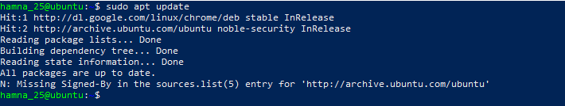

task7_install_chrome_alt.png

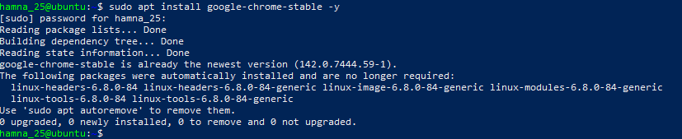

**Task 8 - Install applications via PPA (Audacity & OBS) and launch**

task8_add_ppa_audacity.png (running within XFCE terminal)

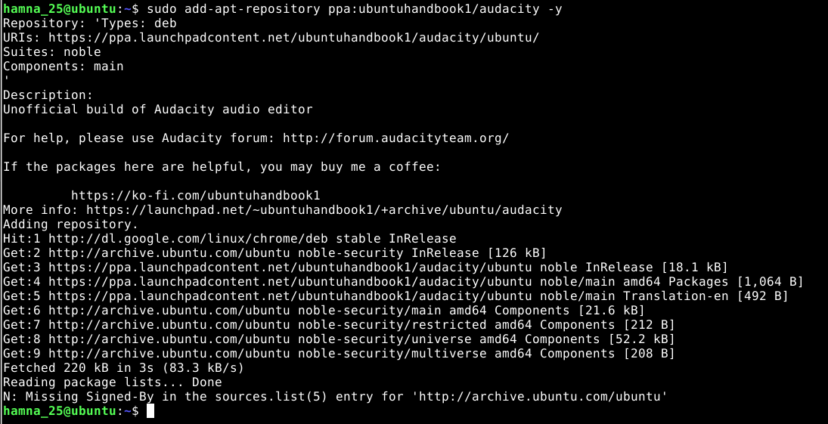

task8_apt_update_audacity.png

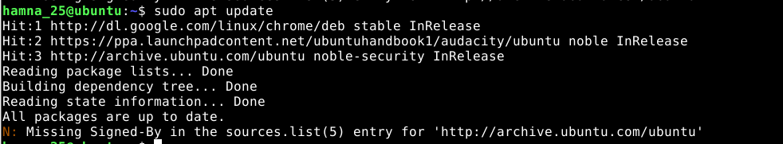task8_install_audacity.png



task8_audacity_launch.png (GUI launch screenshot if possible) or task8_audacity_version.png (CLI verification)

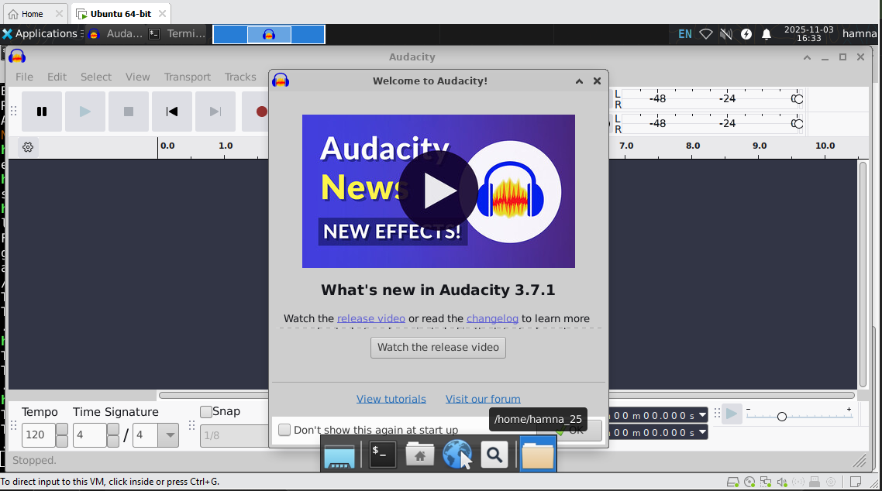

task8_add_ppa_obs.png (output of add-apt-repository)

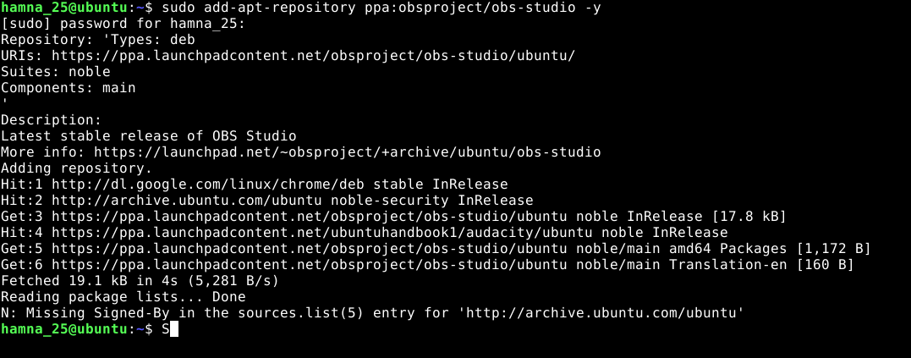

task8_apt_update_obs.png (apt update after adding PPA)

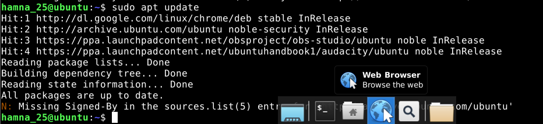

task8_install_obs.png (apt install output)

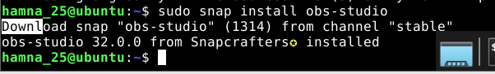

task8_obs_launch.png (GUI launch screenshot if possible) or task8_obs_version.png (CLI verification)

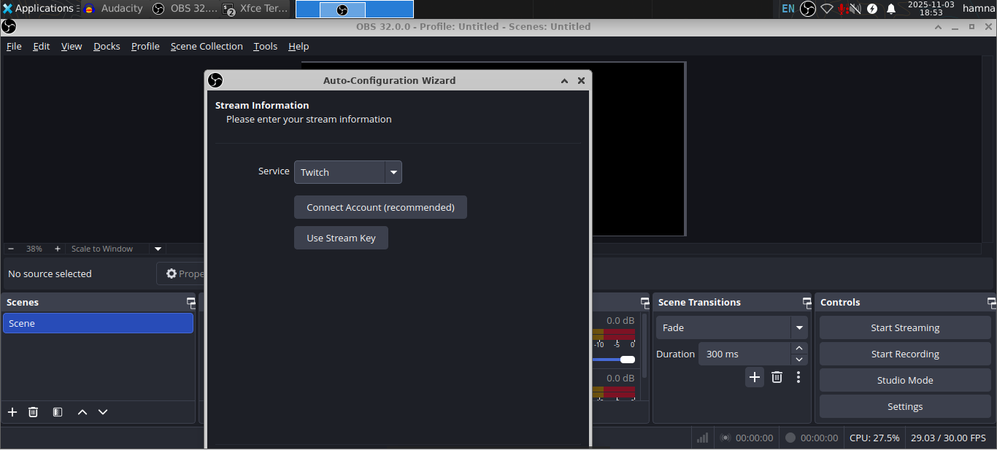

**Task 9 - Create a Kubernetes sample YAML using vim**

task9_vim_check.png



task9_vim_install.png (only if you installed it).

*Mine is already installed*

task9_mkdir_cd.png

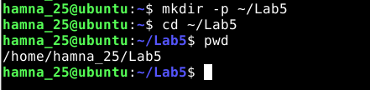

task9_vim_edit.png

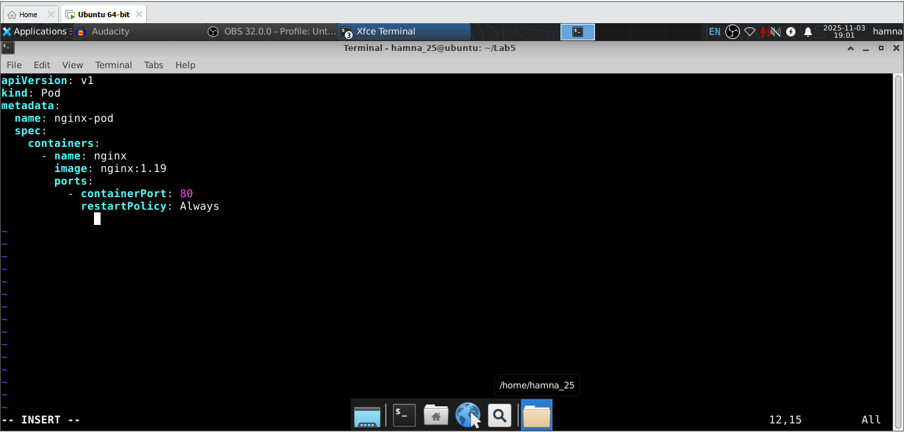

task9_k8s_saved.png

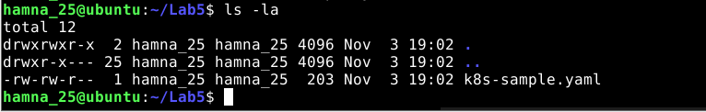

**Task 10 - Edit the Kubernetes YAML - add annotation, verify, then discard temporary change**

task10_verify_annotation.png

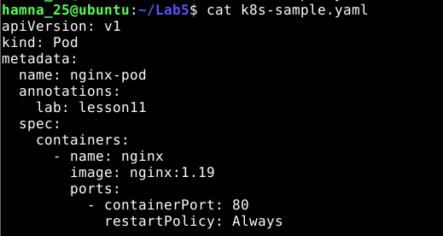

task10_verify_entering_temp_data.png

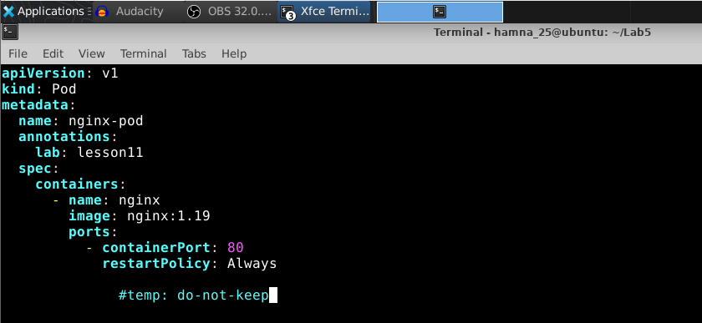

task10_verify_no_temp_comment.png

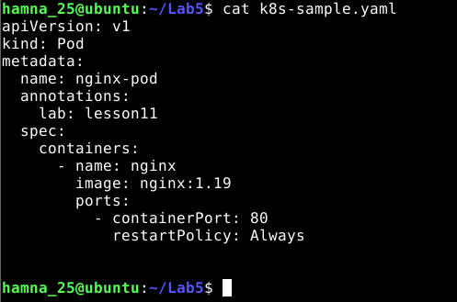

**Task 11 - Vim editing practice - delete, undo, numeric deletes, navigation**

task11_dd_delete_and_undo.png   
*Both images are shown together (before and after)*

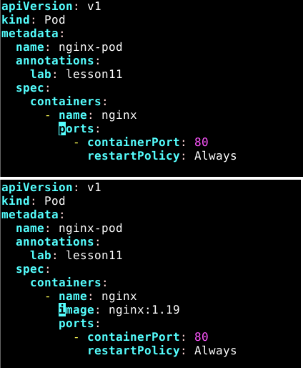

task11_delete3_and_undo.png

*Both images are shown together (before and after)*

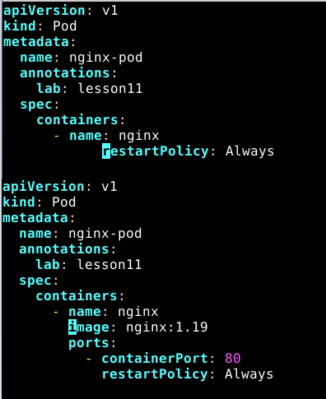

task11_line1.png

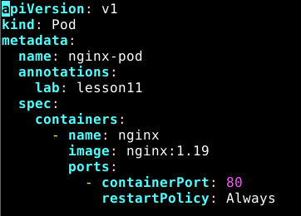

task11_navigation.png

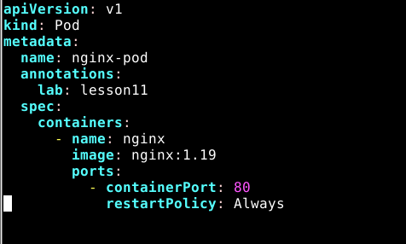

**Task 12 - Vim search, add matches, substitute, undo**

task12_search_nginx.png

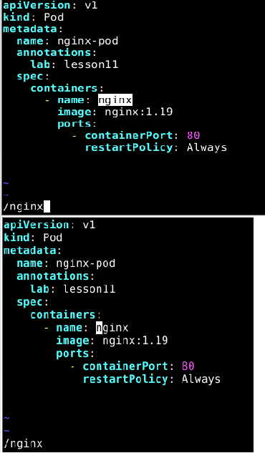

task12_n_and_N_navigation.png

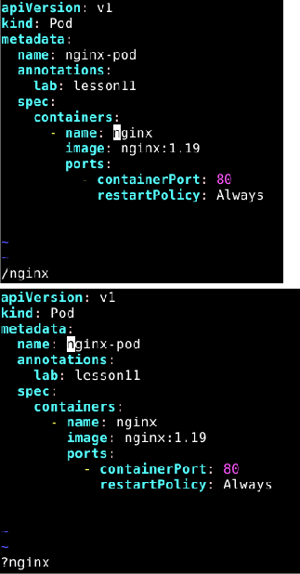

task12_added_occurrences.png

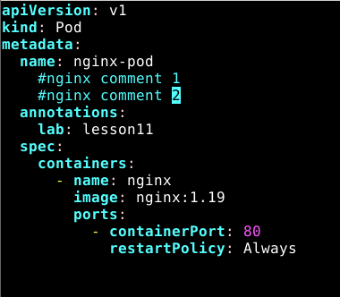

task12_cycle_matches.png

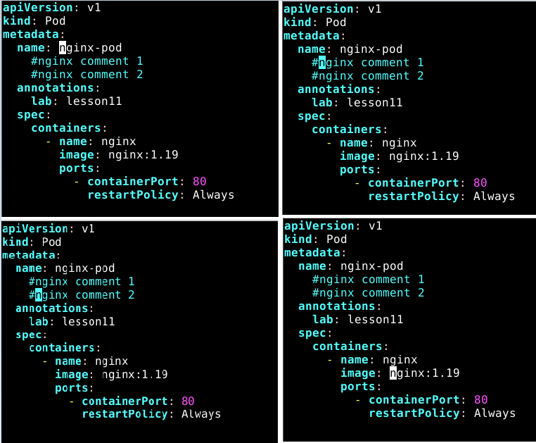

task12_substitute_result.png

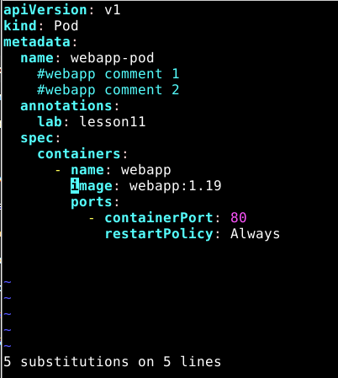

task12_undo_and_quit.png

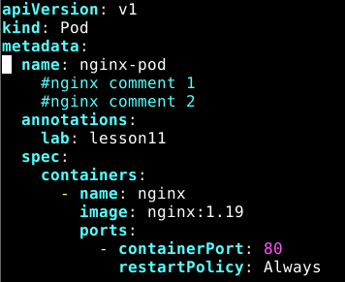

**Exam Evaluation Question**

* **Install Docker Desktop on your VMWare Workstation Ubuntu Server. No commands or solutions are provided in this lab — treat this as an evaluation/exam question.**

**SOLUTION**

First, updating system,

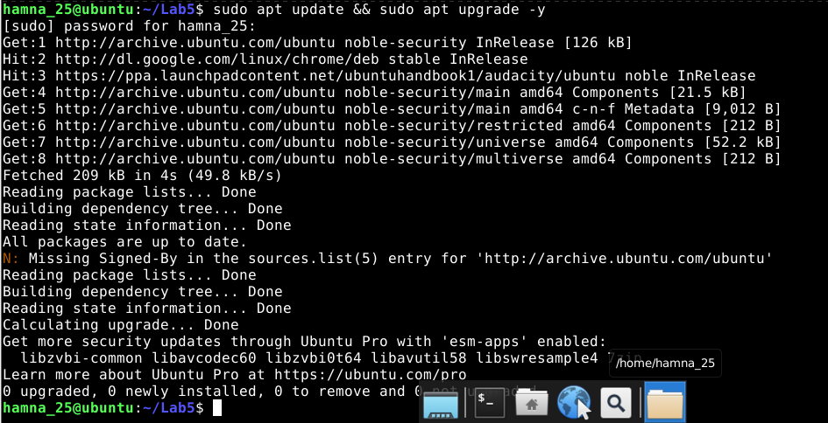

Installing prerequisites,

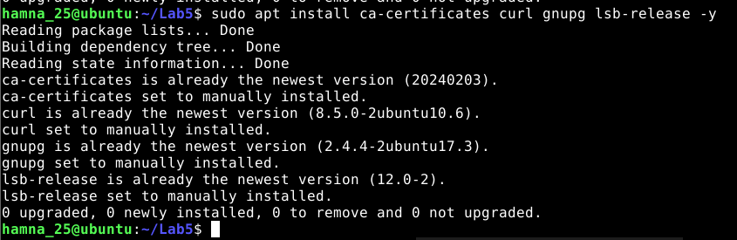

Adding Docker’s official GPG key,



Adding the Docker repository,



Updating apt again,

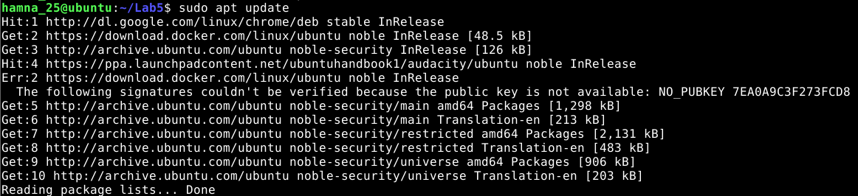

Installing Docker Desktop,

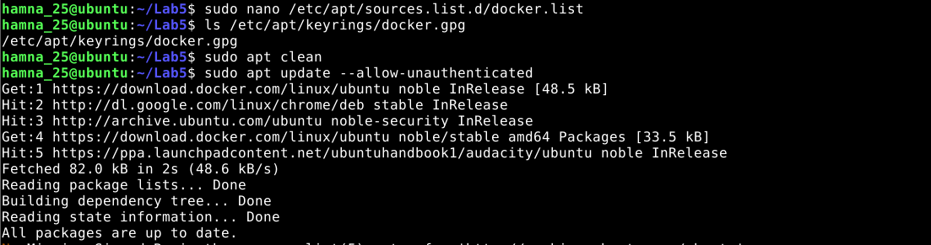

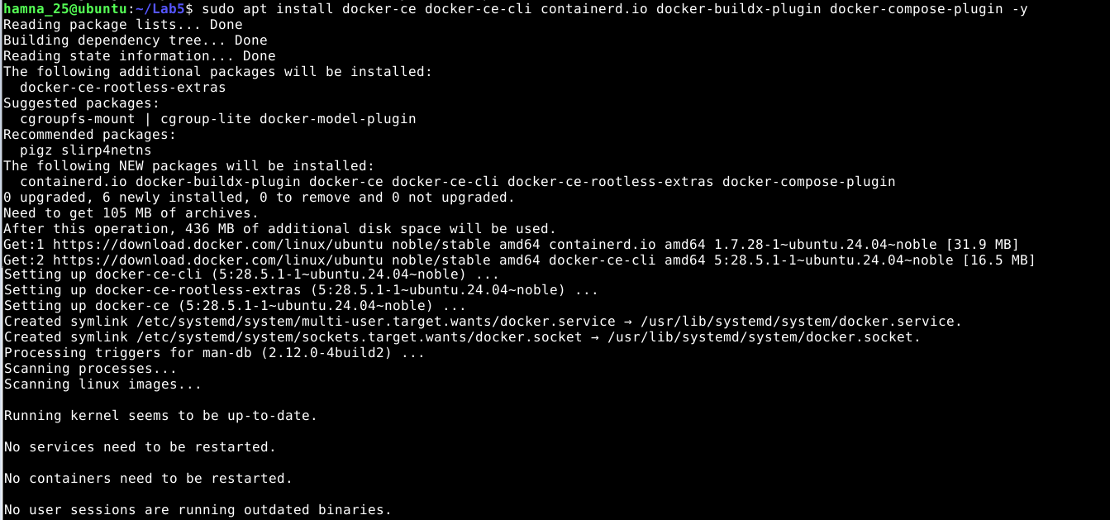

Verify if installed or not,

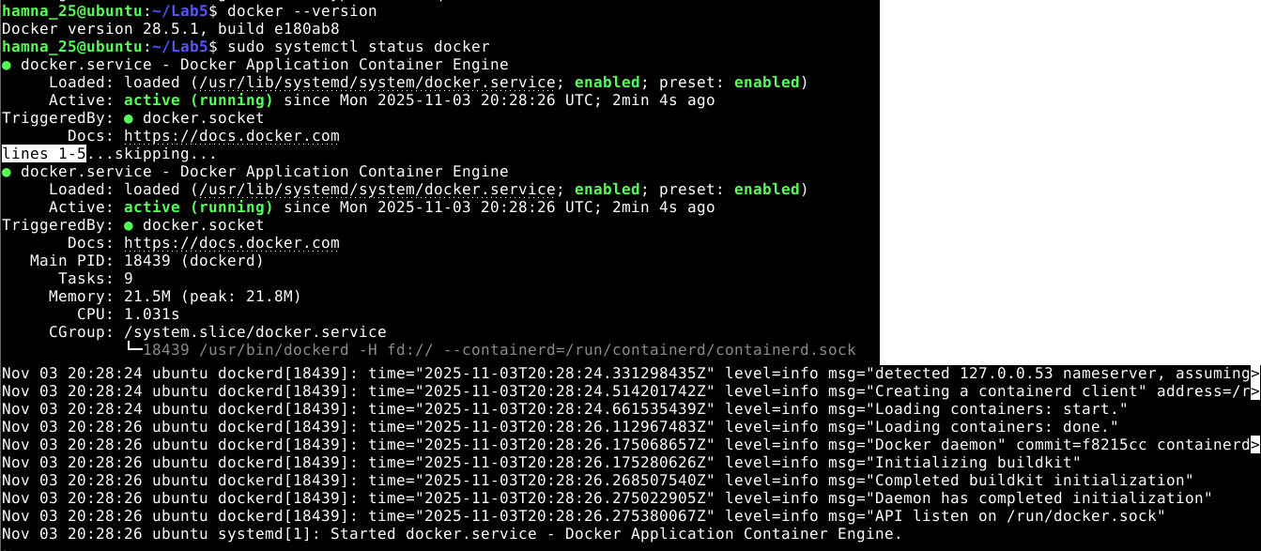

* **Verify Docker Desktop is installed by launching the Docker Desktop application and confirming it runs.**

Verified that Docker Engine was running with:

docker version

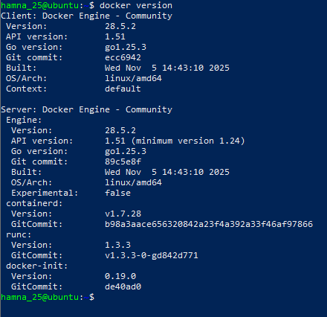

docker info

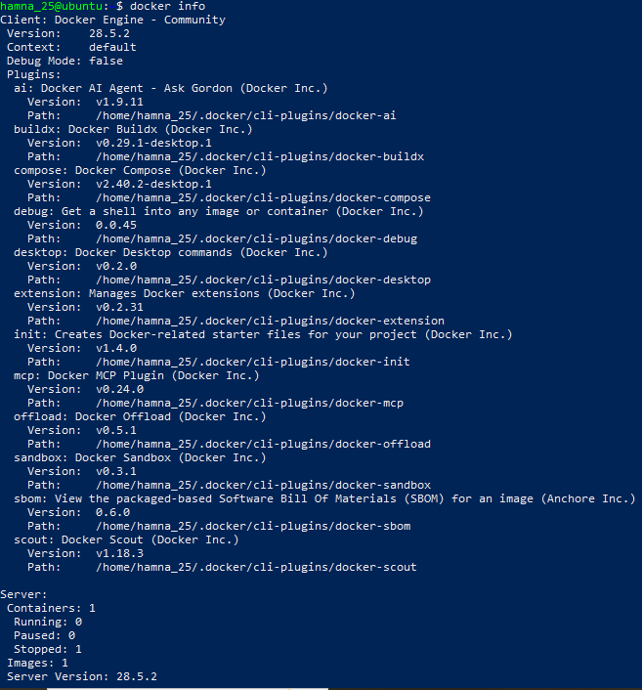

Installing GUI (XFCE) Environment

Run this in your Ubuntu VM terminal: sudo apt update

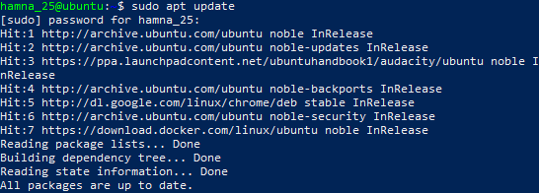

sudo apt install xfce4 xfce4-goodies -y

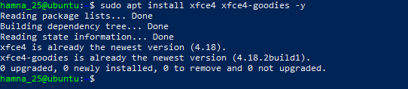

This installs the XFCE desktop and some useful components (lightweight, works well in VMware).  
It may take a few minutes.

Verify or (Re)Enable XRDP for Remote GUI Access

Now let’s ensure you can actually open and *see* the XFCE desktop GUI through VMware (or RDP if needed). Run this command next: sudo systemctl enable --now xrdp



Then check XRDP status: sudo systemctl status xrdp

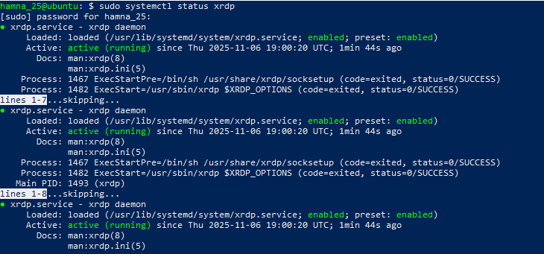

Switch to GUI mode

Run this command in your terminal: sudo systemctl set-default graphical.target

sudo systemctl isolate graphical.target

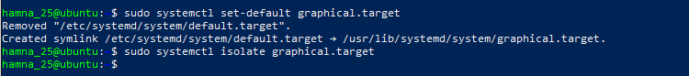

Then, wait a few seconds — your screen should change to a **login window** (the XFCE GUI login).  
If it doesn’t, you can reboot manually: sudo reboot

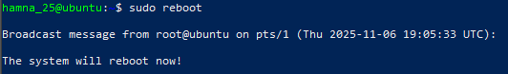

**Started the GUI session manually when in CLI mode:**

sudo systemctl start lightdm

After this:

In VMware, your VM will show a **login screen** (username/password prompt).

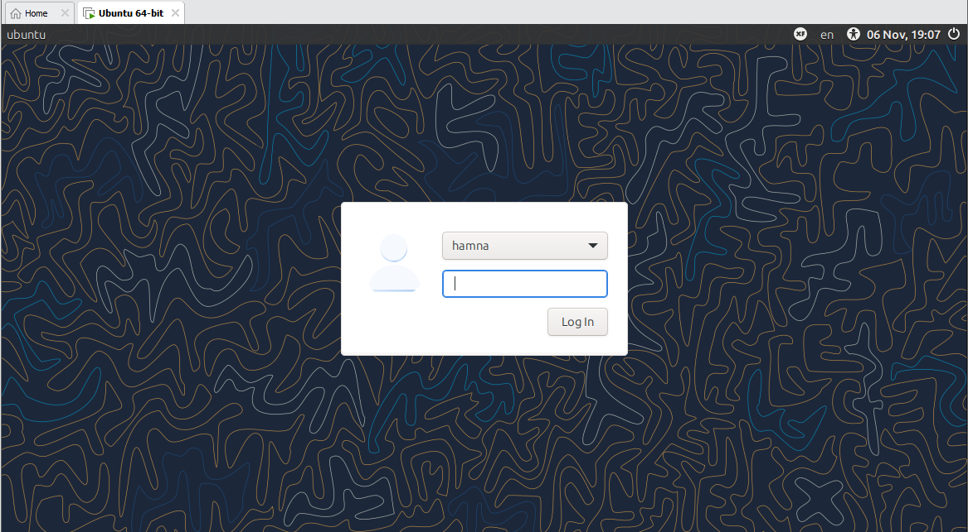

First login.

**Download the Docker Desktop .deb package**

Now that you’re inside XFCE: Click the **blue globe icon** (that’s your web browser).

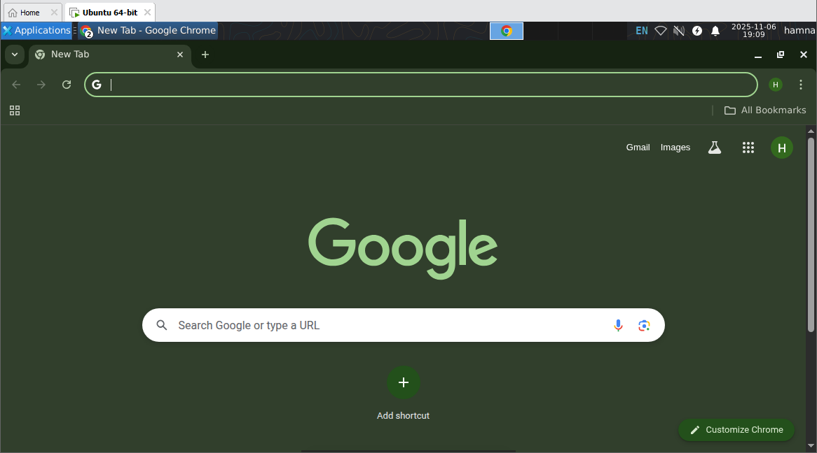

In the browser, go to given link and this automatically download the file:  
[**https://desktop.docker.com/linux/main/amd64/docker-desktop-amd64.deb**](https://desktop.docker.com/linux/main/amd64/docker-desktop-amd64.deb)

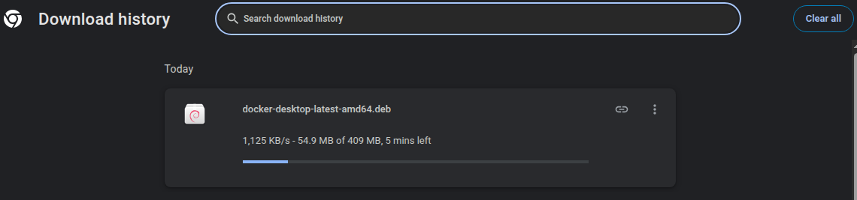

**Install Docker Desktop**

Run the following commands one by one **in your terminal** (you should still be in your home directory ~):

cd ~/Downloads

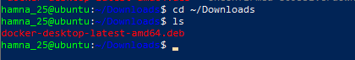

Then install it using:

sudo apt install ./docker-desktop-amd64.deb -y

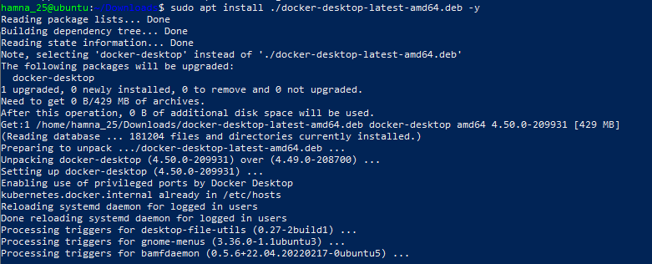

In your **Ubuntu GUI** (XFCE desktop), click the **Applications menu** (usually at the top-left or bottom-left corner).

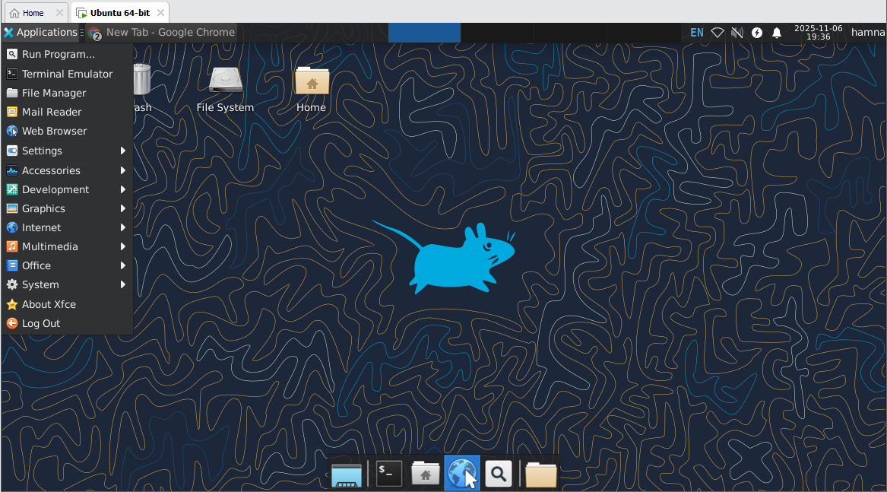

Type **Docker Desktop** in the search bar.

Click on **Docker Desktop** to launch it.

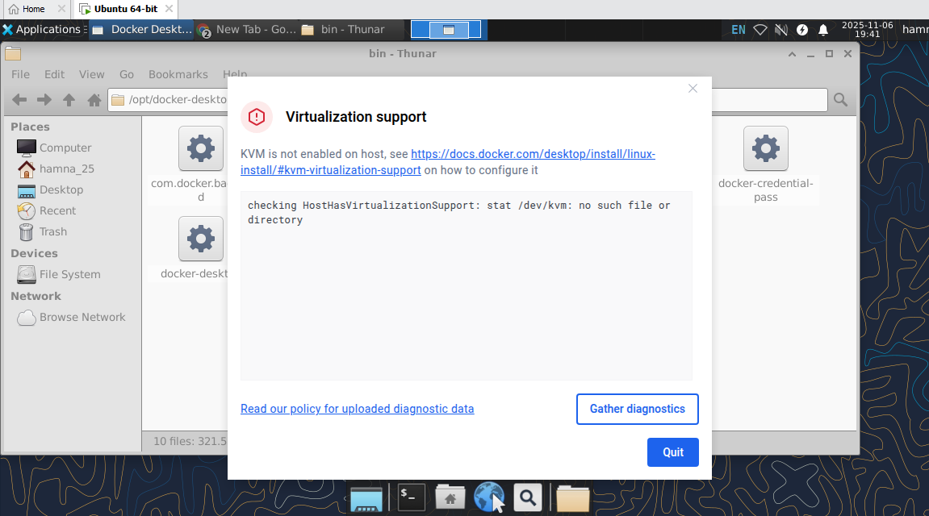 Virtualization Error.

**Solution:**

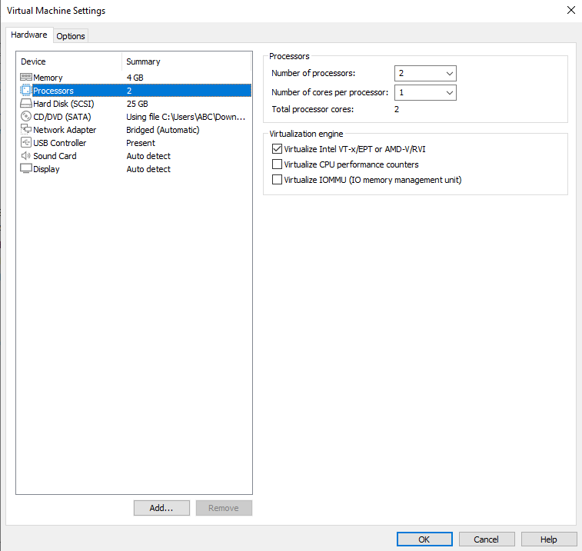

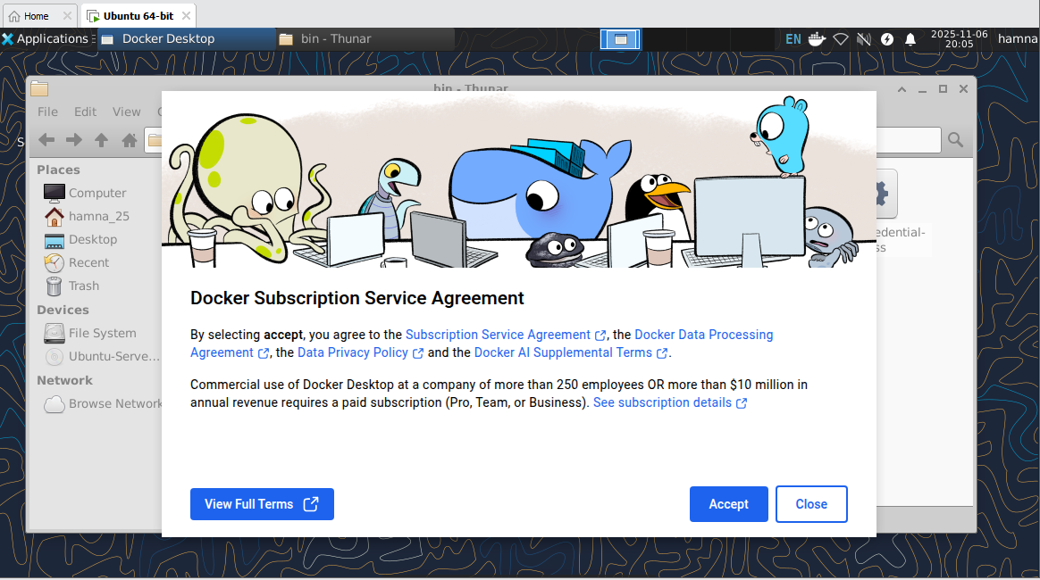

Then wait a bit while Docker Desktop starts up (it might take 30–60 seconds).

Once you see the Docker whale 🐳 icon or the main Docker Desktop window, that means it’s running.

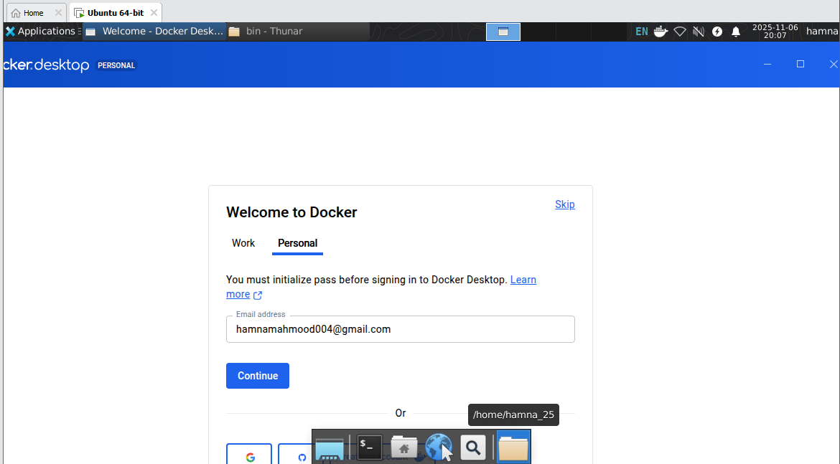

* **Capture a screenshot of Docker Desktop running (or other clear evidence that Docker Desktop is installed and started) and save it as: exam_evaluation_docker_desktop.png**

